- The mkdir command is used to create a new directory :- mkdir test_dir

The touch command is used for empty file:- touch example.txt

The mv command is used to move or rename files and directories:- mv example.txt renamed_example.txt

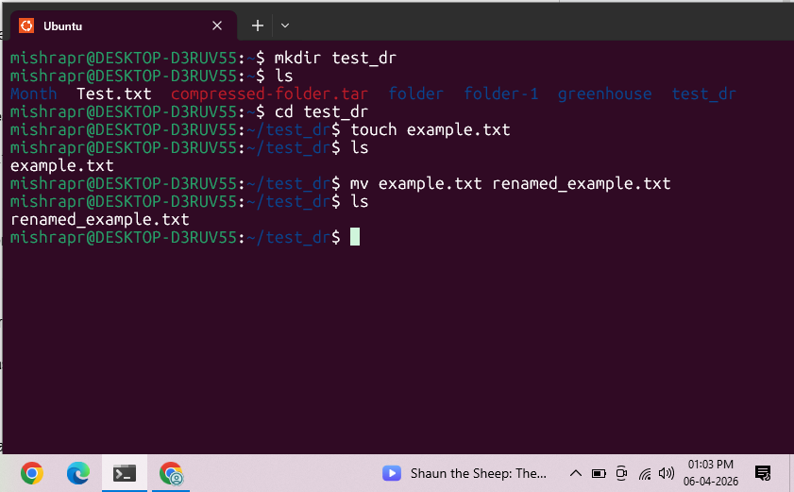

- Viewing File Contents:
The cat command is used to display the entire content of a file.
The head command is used to display the beginning part of a file.
The tail command is used to display the ending part of a file.
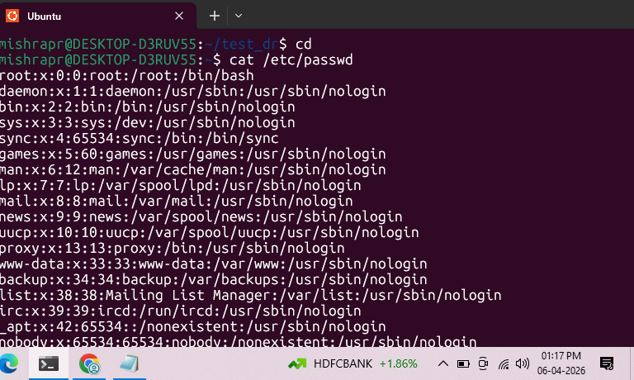
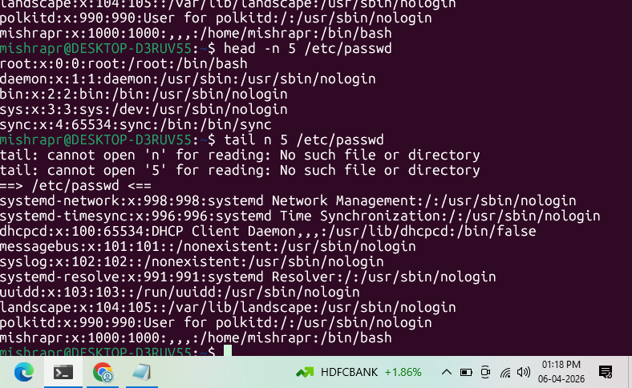

- The grep command is used to search for specific patterns or words within a file.
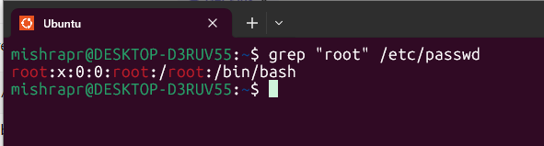

- zip compression command -r recursive test_dir.zip name of zip file test_dir directory to compress and -d unzipped_dir destination directory
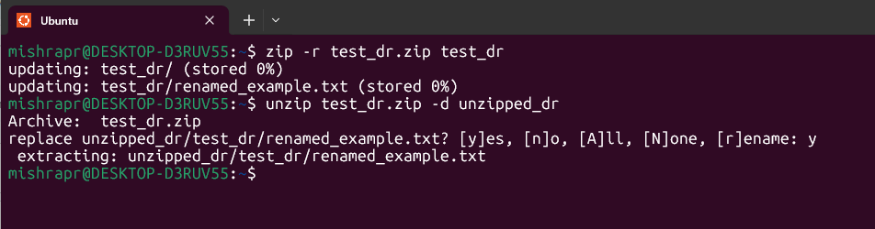

- The wget command is used to download files from the internet directly to your system using a URL.
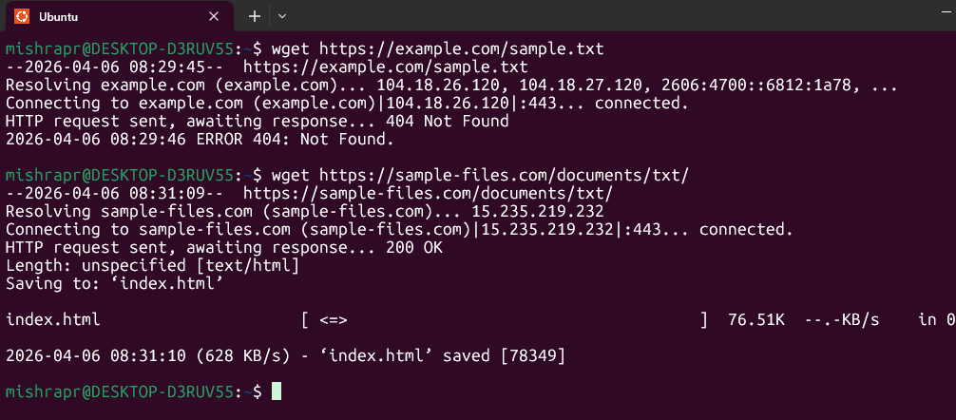

- Touch secure.txt
The chmod command is used to change file permissions in Linux.
444 read-only for all users
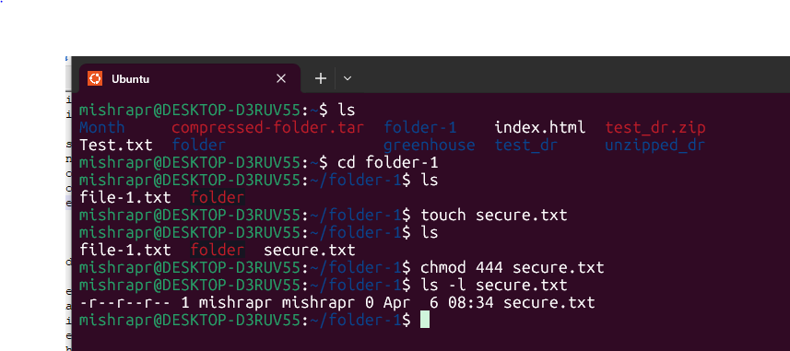

- This command creates an environment variable named MY_VAR with the value Hello, Linux!.
echo - prints the value
$MY_VAR - accesses the variable
